Mrs. Piric’s Class
First Grade Class Supply List

- 1 (2 pack ) Jumbo Ticonderoga brand pencil pack
- 1 one-inch binder
- Headphones
- 12 pencils, Ticonderoga brand
- 2 pink erasers or one pack of pencil topped erasers
- 1 box Crayola brand crayons (24 count)
- Crayon Box 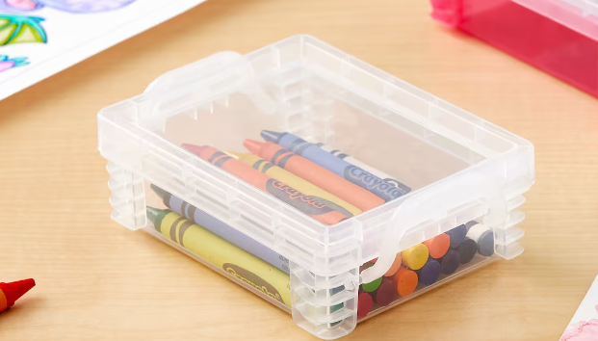
- 2 large Elmers glue sticks
- Pack of Expo Markers
- 3 wide rule, one subject, 70 page spiral bound notebooks, different solid colors, plain front
- 1 Marbled wide ruled composition notebook
- 1 box of tissues
- 1 roll of paper towels
- Soft zippered pencil case
- 3 plain, two pocket folders
- 1 bag of Ziploc gallon bags or 1 box of quart sized Ziploc bags
- 1 container of Lysol or Clorox disinfectant wipes

Please label as many items as possible with your child’s name.

